175th anniversary polos
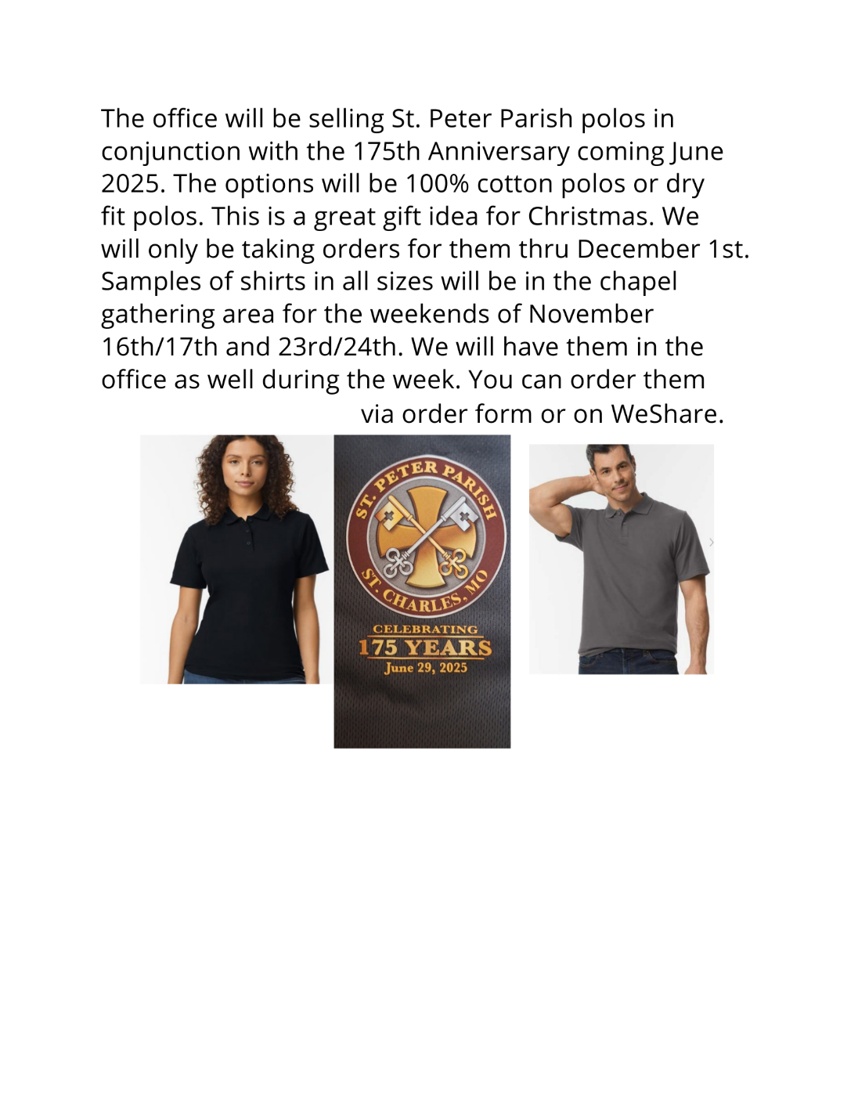
Name ____________________________________________________
Address _____________________________________________________
_____________________________________________________
Phone & Email _______________________________________________

PLEASE INCLUDE THE SIZE YOU WISH TO ORDER.
COTTON POLOS
Mens Color | White | Black | Charcoal | Total Price
SAMPLE |  | 1M, 1XL |  | $32
$16 (S/M/L/XL)
$18
2XL or 3XL
Womens Color | White | Black | Maroon | Total Price
$17 (S/M/L/XL)
$18 (2XL)

DRY FIT POLO (GRAPHITE ONLY)
Mens | # | Size | Total Price
$18 (S/M/L/XL)
$19 |  | 2XL
$21 |  | 3XL
$22 |  | 4XL
Womens | # | Size | Total Price
$18 (S/M/L/XL)
$19 |  | 2XL
$20 |  | 3XL

Youth Sizes, Cotton | Black | Maroon | Total Price
$16 (S/M/L)
$17 (XL)

